1. **Create ERD**

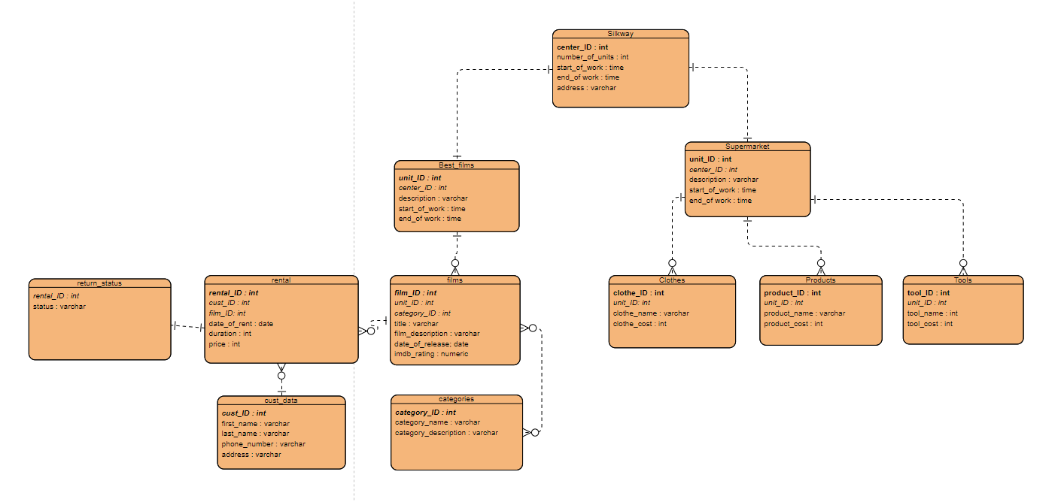

1. **Create database**

create table SILKWAY

(

center_id INT primary key,

number_of_units INT,

start_of_work TIME,

end_of_work TIME,

address VARCHAR(32)

);

create table BEST_FILMS

(

unit_id INT primary key,

center_id INT,

description VARCHAR(255),

start_of_work TIME,

end_of_work TIME,

FOREIGN KEY (center_id)

REFERENCES SILKWAY (center_id)

);

create table categories

(

category_id INT primary key,

category_name VARCHAR(255),

category_description VARCHAR

);

create table films

(

film_id INT primary key,

unit_id INT,

category_id INT,

title VARCHAR(255),

film_description VARCHAR,

date_of_release VARCHAR,

imdb_score NUMERIC,

FOREIGN KEY (unit_id)

REFERENCES BEST_FILMS (unit_id),

FOREIGN KEY (category_id)

REFERENCES categories (category_id)

);

create table cust_data

(

cust_id INT primary key,

first_name VARCHAR(255),

last_name VARCHAR(255),

phone_number VARCHAR(255),

address VARCHAR

);

create table rental

(

rental_id INT primary key,

cust_id INT,

film_id INT,

date_of_rent DATE,

duration INT,

price INT,

FOREIGN KEY (film_id)

REFERENCES films (film_id),

FOREIGN KEY (cust_id)

REFERENCES cust_data (cust_id)

);

create table return_status

(

rental_id INT primary key,

status VARCHAR(255),

FOREIGN KEY (rental_id)

REFERENCES rental (rental_id)

);

create table supermarket

(

unit_id INT primary key,

center_id INT,

description VARCHAR,

start_of_work TIME,

end_of_work TIME,

FOREIGN KEY (center_id)

REFERENCES SILKWAY (center_id)

);

create table clothes

(

clothe_id INT primary key,

unit_id INT,

clothe_name VARCHAR(255),

clothe_cost INT,

FOREIGN KEY (unit_id)

REFERENCES supermarket (unit_id)

);

create table products

(

product_id INT primary key,

unit_id INT,

product_name VARCHAR(255),

product_cost INT,

FOREIGN KEY (unit_id)

REFERENCES supermarket (unit_id)

);

create table tools

(

tool_id INT primary key,

unit_id INT,

tool_name VARCHAR(255),

tool_cost INT,

FOREIGN KEY (unit_id)

REFERENCES supermarket (unit_id)

);

1. **Write 5 different ALTER TABLE statements**

ALTER TABLE tools

ADD Description VARCHAR;

ALTER TABLE tools

DROP column description;

1. **Write SQL query for DML statement**

**INSERT**

insert into

silkway (center_id, number_of_units, start_of_work, end_of_work, address)

values

(2,2,'08:00','20:00', 'Kabanbai Batyr 62');

insert into

supermarket (unit_id, center_id, description, start_of_work, end_of_work)

values

(1,2,'A supermarket is a self-service shop offering a wide variety of food, beverages and household products, organized into sections','08:15', '19:45');

insert into

tools (tool_id, unit_id, tool_name, tool_cost)

values

(1,1,'pencil',100),

(2,1,'pen',200),

(3,1,'screwdriver',1500),

(4,1,'lock',800),

(5,1,'knife',500),

(6,1,'drill',5000),

(7,1,'hammer',1200),

(8,1,'paintbrush',500),

(9,1,'ruler',350),

(10,1,'sharpener',150);

insert into

products (product_id, unit_id, product_name, product_cost)

values

(1,1,'apple',90),

(2,1,'banana',120),

(3,1,'wine',2090),

(4,1,'onion',160),

(5,1,'fish',1050),

(6,1,'bread',70),

(7,1,'chicken',1200),

(8,1,'souce',465),

(9,1,'gum',240),

(10,1,'chips',570);

insert into

clothes (clothe_id, unit_id, clothe_name, clothe_cost)

values

(1,1,'pants',5700),

(2,1,'t-shirt',6180),

(3,1,'hat',4320),

(4,1,'socks',2500),

(5,1,'sneakers',8000),

(6,1,'glasses',1700),

(7,1,'coat',9600),

(8,1,'panties',7940),

(9,1,'jacket',7410),

(10,1,'skirt',9635);

insert into

categories (category_id, category_name, category_description)

values

(1,'fantastic','The fantastic is present in works where the reader experiences hesitation about whether a work presents what Todorov calls "the uncanny", wherein superficially supernatural phenomena turn out to have a rational explanation (such as in the Gothic works of Ann Radcliffe) or "the marvelous", where the supernatural is confirmed by the story.'),

(2,'drama','Drama is a category of narrative fiction (or semi-fiction) intended to be more serious than humorous in tone.'),

(3,'fantasy','Fantasy is a genre of speculative fiction set in a fictional universe, often inspired by real world myth and folklore.'),

(4,'adventure','Adventure fiction is a genre of fiction that usually presents danger, or gives the reader a sense of excitement.'),

(5,'biography','A biography, or simply bio, is a detailed description of a persons life.'),

(6,'melodrama','In modern usage, a melodrama is a dramatic work wherein the plot, which is typically sensational and designed to appeal strongly to the emotions, takes precedence over detailed characterization.'),

(7,'comedy','Comedy is any work that is intended to incite laughter and amusement, especially in theatre, television, film, stand-up comedy or any other entertainment medium.'),

(8,'family','Family film is a genre of film production that is designed for interested perception by different age groups of both sexes at the same time, and thus is suitable for watching the film with the whole family.'),

(9,'cartoon','A film made with the help of animation means, that is, frame-by-frame recording of volumetric and flat images created by the artist or objects of the real-world world on film and video tape or on digital media.'),

(10,'crime','It is a film genre inspired by and analogous to the crime fiction literary genre. Films of this genre generally involve various aspects of crime and its detection.');

insert into

films (film_id, unit_id, category_id,title,film_description,date_of_release,imdb_score)

values

(1,2,10,'The Green Mile','A prisoner with a divine gift appears in the death row. Mystical drama based on the novel by Stephen King',1999,9.0),

(2,2,2,'The Shawshank Redemption','Trapped in a prison called Shawshenko, Andy Dufraim is faced with the brutality and lawlessness that reigns on both sides of the bars. Everyone who falls into these walls becomes their slave for the rest of their lives. But Andy, with a lively mind and a kind soul, finds an approach to both prisoners and guards, seeking their special favor',1994,8.9),

(3,2,3,'The Lord of the Rings: The Return of the King','The last part of the trilogy about the Ring of Omnipotence and about the heroes who took on the burden of saving Middle-earth',2003,8.8),

(4,2,1,'Interstellar','A fantastic epic about a choking Earth, space flights and paradoxes of time. Oscar for special effects',2014,8.8),

(5,2,5,'Schindlers List','A drama about the Holocaust and a great human act',1993,8.7),

(6,2,4,'The Lord of the Rings: The Fellowship of the Ring','Tales of Middle-earth chronicles the Great War of the Ring, a war that lasted for thousands of years. The one who owned the Ring received power over all living things, but was obliged to serve evil.',2001,8.7),

(7,2,6,'Forrest Gump','Tom Hanks fulfills the American dream',1994,8.7),

(8,2,3,'The Lord of the Rings: The Two Towers','The Brotherhood has disintegrated, but the Ring of Omnipotence must be destroyed. Frodo and Sam are forced to entrust their lives to Gollum, who undertook to lead them to the gates of Mordor. The immense Army of Saruman is approaching: the members of the brotherhood and their allies are ready to fight. The battle for Middle-earth continues',2002,8.7),

(9,2,7,'Intouchables','Former convict restores a taste for life to a prim aristocrat chained to a wheelchair',2011,8.7),

(10,2,9,'Klaus','The owner of the postal empire, in order to teach a lazy offspring named Jesper wisdom, sends him to the far north in the city of Smirensburg',2019,8.6);

insert into

cust_data (cust_id, first_name, last_name, phone_number, address)

values

(1, 'Nessa', 'Balfour', '995-852-0894', '55398 Lakewood Gardens Circle'),

(2, 'Olympie', 'Croster', '289-147-4779', '79169 Mitchell Avenue'),

(3, 'Poul', 'Piatek', '226-747-7462', '76288 Gateway Plaza'),

(4, 'Louie', 'De Bruijne', '521-416-1156', '7829 Center Place'),

(5, 'Kelcey', 'Bacher', '589-127-1167', '090 Elgar Hill'),

(6, 'Court', 'Donnel', '927-561-0196', '7638 Ridgeview Drive'),

(7, 'Olimpia', 'Tickel', '206-129-1162', '04809 Logan Alley'),

(8, 'Netty', 'Yeskov', '448-636-3544', '70 Texas Hill'),

(9, 'Dusty', 'Nethercott', '577-943-4431', '7 Forest Way'),

(10, 'Winnie', 'Verrier', '938-857-9099', '58879 Fairview Junction');

insert into

return_status (rental_id, cust_id, film_id, date_of_rent, duration, price)

values

(1, 3, 9, '2020-10-03', 16, 2000),

(2, 6, 9, '2020-10-27', 5, 500),

(3, 5, 2, '2020-11-07', 12, 1000),

(4, 10, 10, '2020-10-12', 7, 1000),

(5, 10, 5, '2020-10-25', 6, 500),

(6, 4, 1, '2020-11-05', 21, 4000),

(7, 10, 8, '2020-10-04', 2, 500),

(8, 1, 6, '2020-10-21', 13, 1000),

(9, 7, 3, '2020-10-10', 17, 2000),

(10, 3, 3, '2020-10-07', 3, 500);

insert into

return_status (rental_id, status)

values

(1, 'Returned'),

(2, 'Returned'),

(3, 'Not returned'),

(4, 'Returned'),

(5, 'Returned'),

(6, 'Not returned'),

(7, 'Returned'),

(8, 'Returned'),

(9, 'Returned'),

(10, 'Returned');

**UPDATE**

UPDATE return_status

SET status = 'Not returned'

WHERE rental_id = 8;

UPDATE cust_data

SET first_name = 'Nick'

WHERE first_name = 'Dusty';

UPDATE films

SET category_id = 4

WHERE film_id = 8;

UPDATE films

SET category_id = 4

WHERE film_id = 3;

UPDATE tools

SET tool_name = 'eraser'

WHERE tool_cost = (select min(tool_cost) from tools)

ALTER TABLE tools

ADD Description VARCHAR;

ALTER TABLE tools

DROP column description;

**DELETE**

DELETE FROM products

WHERE product_cost = (select min(product_cost) from products);

DELETE FROM products

WHERE product_cost = (select min(product_cost) from products);

DELETE FROM products

WHERE product_cost = (select min(product_cost) from products);

**5.**

SELECT first_name, last_name

from cust_data

join rental on cust_data.cust_id = rental.cust_id

join return_status on return_status.rental_id = rental.rental_id

WHERE return_status.status = 'Not returned';

SELECT sum(price) as total_income

from rental;

select AVG(tool_cost)

from tools;

select title, categories.category_name

from films join categories on films.category_id = categories.category_id;

select distinct rental.cust_id, cust_data.first_name, cust_data.last_name

from rental join cust_data on rental.cust_id = cust_data.cust_id

ORDER BY cust_id ASC

**6.**

select title

from films join categories on films.category_id = categories.category_id

where films.category_id = (select category_id from films where film_id = 6);